Reviewed: March 2018

Review Date: March 2019

###### St Mary’s Primary School, Dunsford



###### Online Safety Pupil Agreement (KS1)

*Article 3*

*The best interests of the child must be a top priority in all things*

*Article19*

*You have the right to be protected from being hurt and mistreated, in body or mind.*

*Article 36*

*Children have the right to be protected from all other forms of bad treatment*

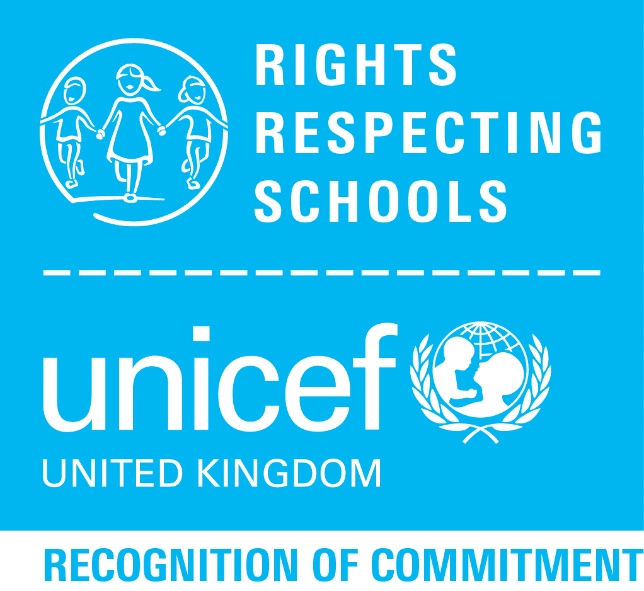



Pupil Acceptable Use Policy Agreement – (KS1)

#### This is how we stay safe when we use computers:

* I will ask a teacher or suitable adult if I want to use the computers / tablets.
* I will only use activities that a teacher or suitable adult has told or allowed me to use.
* I will take care of the computer and other equipment.
* I will ask for help from a teacher or suitable adult if I am not sure what to do or if I think I have done something wrong.
* I will tell a teacher or suitable adult if I see something that upsets me on the screen.
* I know that if I break the rules I might not be allowed to use a computer / tablet.

Signed (child):

Signed (parent):

Date: